**Lab 8_1. JavaScript Behind the scenes. JavaScript in the Browser.**

**Task 1.** **Developer Skills & Editor Setup**

Given an array of forecasted maximum temperatures, the thermometer displays a string with the given temperatures. **Example:** [17, 21, 23] will print *"... 17ºC in 1 days ... 21ºC in 2 days ... 23ºC in 3 days ..."*

### Your tasks:

1. Create a function 'printForecast' which takes in an array 'arr' and logs a string like the above to the console. Try it with both test datasets.
2. Use the problem-solving framework: Understand the problem and break it up into sub-problems!

### Test data:

* Data 1: [17, 21, 23]
* Data 2: [12, 5, -5, 0, 4]

let printForecast = (array) => {

    for(let i = 0; i < array.length; i++){

        console.log(`${array[i]}ºC in ${i+1} days...`)

    }

}

const data1 = [17,21,23];

const data2 = [12,5,-5,0,4];

printForecast(data1);

printForecast(data2);

In this task I used array and ‘for’ and just write in console degrees.

Result:

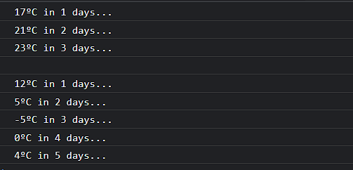

**Task 2. DOM and Events**

Implement a game rest functionality, so that the player can make a new guess!

### Your tasks:

1. Select the element with the 'again' class and attach a click event handler
2. In the handler function, restore initial values of the 'score' and

'secretNumber' variables

1. Restore the initial conditions of the message, number, score and guess input fields
2. Also restore the original background color (#222) and number width (15rem)

document.body.append(document.createElement('textarea'));

document.body.append(document.createElement('button'));

const text = document.querySelector('textarea');

const button = document.querySelector('button');

let randomNumber = Math.floor(Math.random()*11);

let score = 0;

// console.log(randomNumber);

button.addEventListener('click', function() {

    let guessNumber = text.value;

    if(guessNumber == randomNumber){

        console.log('You guessed number');

        score++;

        randomNumber = Math.floor(Math.random()*11);

    }

    else{

        console.log('Try again');

    }

    console.log(`Score: ${score}`);

});

I used textarea and button from last lab work and create variable with random number and with “if, else” create simple guess number game, randomly guessing number range 1-10. If we guess +score and random number refreshing.

Result:

